2200030216 JUNIT SAMPLE TESTING

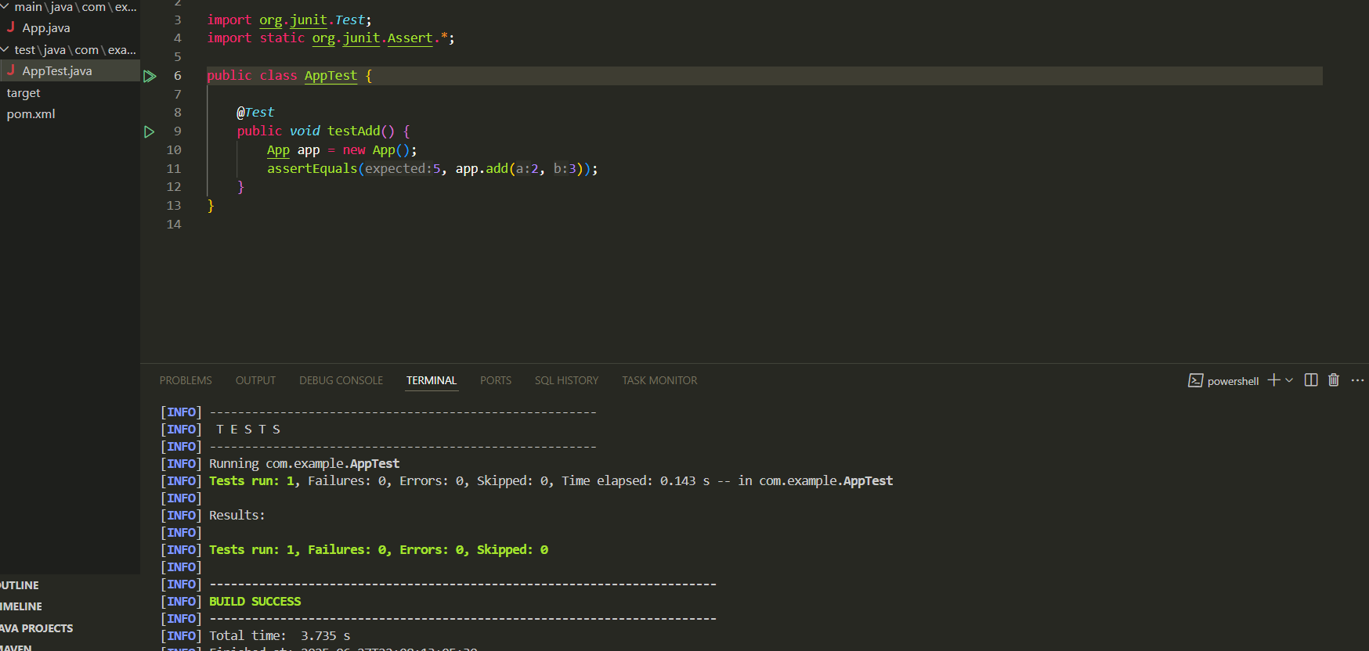

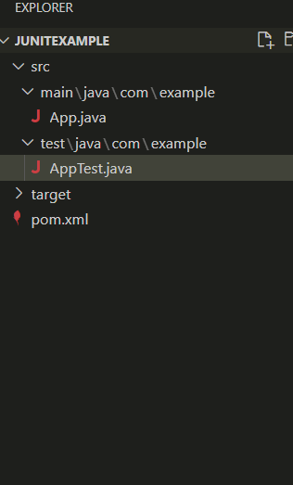

Apptest.java  
package com.example;

import org.junit.*Test*;

import static org.junit.Assert.\*;

public class AppTest {

    @*Test*

    public *void* testAdd() {

        App app = new App();

        assertEquals(5, app.add(2, 3));

    }

}

App.java

package com.example;

public class App {

    public *int* add(*int* *a*, *int* *b*) {

        return *a* + *b*;

    }

    public static *void* main(String[] *args*) {

        App app = new App();

        System.out.println("Sum: " + app.add(2, 3));

    }

}